# [ggplot2](https://www.amazon.com/ggplot2-Elegant-Graphics-Data-Analysis/dp/331924275X" \o "Link added by VigLink) – Easy way to mix multiple graphs on the same page

To arrange **multiple** [**ggplot2**](https://www.amazon.com/ggplot2-Elegant-Graphics-Data-Analysis/dp/331924275X) graphs on the same page, the standard R functions – *par()* and *layout()* – cannot be used.

The basic solution is to use the **[gridExtra](https://github.com/baptiste/gridextra/wiki/arrangeGrob" \t "_blank)** R package, which comes with the following functions:

* *grid.arrange*() and *arrangeGrob*() to arrange multiple ggplots on one page
* *marrangeGrob*() for arranging multiple ggplots over multiple pages.

However, these functions makes no attempt at aligning the plot panels; instead, the plots are simply placed into the grid as they are, and so the [axes](http://www.amazon.com/gp/search?ie=UTF8&camp=1789&creative=9325&index=aps&keywords=axes&linkCode=ur2) are not aligned.

If axis alignment is required, you can switch to the **[cowplot](https://cran.r-project.org/web/packages/cowplot/vignettes/introduction.html" \t "_blank)** package, which include the function **plot\_grid**() with the argument *align*. However, the cowplot package doesn’t contain any solution for multi-pages layout. Therefore, we provide the function **ggarrange**() [in ggpubr], a wrapper around the plot\_grid() function, to arrange multiple ggplots over multiple pages. It can also create a common unique legend for multiple plots.

This article will show you, step by step, how to combine multiple **ggplots** on the same page, as well as, over multiple pages, using helper functions available in the following R package: **[ggpubr](http://www.sthda.com/english/rpkgs/ggpubr/index.html" \t "_blank)** [R package](http://www.sthda.com/english/rpkgs/ggpubr/index.html" \t "_blank), **cowplot** and **gridExtra**. We’ll also describe how to export the arranged plots to a file.

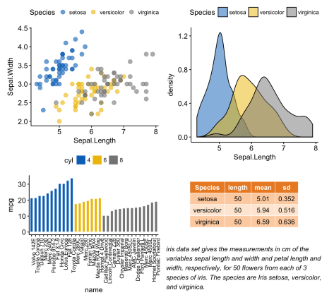

**Contents**:

* [Prerequisites](http://www.sthda.com/english/wiki/ggplot2-easy-way-to-mix-multiple-graphs-on-the-same-page" \l "prerequisites" \t "_blank)
* [Create some plots](http://www.sthda.com/english/wiki/ggplot2-easy-way-to-mix-multiple-graphs-on-the-same-page" \l "create-some-plots" \t "_blank)
* [Arrange on one page](http://www.sthda.com/english/wiki/ggplot2-easy-way-to-mix-multiple-graphs-on-the-same-page" \l "arrange-on-one-page" \t "_blank)
* [Annotate the arranged figure](http://www.sthda.com/english/wiki/ggplot2-easy-way-to-mix-multiple-graphs-on-the-same-page" \l "annotate-the-arranged-figure" \t "_blank)
* [Align plot panels](http://www.sthda.com/english/wiki/ggplot2-easy-way-to-mix-multiple-graphs-on-the-same-page" \l "align-plot-panels" \t "_blank)
* [Change column/row span of a plot](http://www.sthda.com/english/wiki/ggplot2-easy-way-to-mix-multiple-graphs-on-the-same-page" \l "change-columnrow-span-of-a-plot" \t "_blank)
* [Use common legend for combined ggplots](http://www.sthda.com/english/wiki/ggplot2-easy-way-to-mix-multiple-graphs-on-the-same-page" \l "use-common-legend-for-combined-ggplots" \t "_blank)
* [Scatter plot with marginal density plots](http://www.sthda.com/english/wiki/ggplot2-easy-way-to-mix-multiple-graphs-on-the-same-page" \l "scatter-plot-with-marginal-density-plots" \t "_blank)
* [Mix table, text and ggplot2 graphs](http://www.sthda.com/english/wiki/ggplot2-easy-way-to-mix-multiple-graphs-on-the-same-page" \l "mix-table-text-and-ggplot" \t "_blank)
* [Insert a graphical element inside a ggplot](http://www.sthda.com/english/wiki/ggplot2-easy-way-to-mix-multiple-graphs-on-the-same-page" \l "insert-a-graphical-element-inside-a-ggplot" \t "_blank)
* [Arrange over multiple pages](http://www.sthda.com/english/wiki/ggplot2-easy-way-to-mix-multiple-graphs-on-the-same-page" \l "arrange-over-multiple-pages" \t "_blank)
* [Nested layout with ggarrange()](http://www.sthda.com/english/wiki/ggplot2-easy-way-to-mix-multiple-graphs-on-the-same-page" \l "nested-layout-with-ggarrange" \t "_blank)
* [Export plots](http://www.sthda.com/english/wiki/ggplot2-easy-way-to-mix-multiple-graphs-on-the-same-page" \l "export-plots" \t "_blank)
* [Acknoweledgment](http://www.sthda.com/english/wiki/ggplot2-easy-way-to-mix-multiple-graphs-on-the-same-page" \l "acknoweledgment" \t "_blank)
* [Infos](http://www.sthda.com/english/wiki/ggplot2-easy-way-to-mix-multiple-graphs-on-the-same-page" \l "infos" \t "_blank)

**Prerequisites**

**Required R package**

You need to install the R package [ggpubr (version >= 0.1.3)](http://www.sthda.com/english/rpkgs/ggpubr" \t "_blank), to easily create ggplot2-based publication ready plots.

We recommend to install the latest developmental version from [GitHub](https://github.com/kassambara/ggpubr" \t "_blank) as follow:

if(!require(devtools)) install.packages("devtools") devtools::install\_github("kassambara/ggpubr")

If installation from Github failed, then try to install from [CRAN](https://cran.r-project.org/package=ggpubr" \t "_blank) as follow:

install.packages("ggpubr")

[Note](https://www.amazon.com/s/ref=nb_sb_noss?url=search-alias%3Daps&field-keywords=note) that, the installation of **ggpubr** will install the **gridExtra** and the **cowplot** package; so you don’t need to re-install them.

Load ggpubr:

library(ggpubr)

**Demo data sets**

Data: [ToothGrowth](http://www.sthda.com/english/wiki/r-built-in-data-sets" \l "toothgrowth" \t "_blank) and [mtcars](http://www.sthda.com/english/wiki/r-built-in-data-sets" \l "mtcars-motor-trend-car-road-tests" \t "_blank) data sets.

# ToothGrowth data("ToothGrowth") head(ToothGrowth)

len supp dose 1 4.2 VC 0.5 2 11.5 VC 0.5 3 7.3 VC 0.5 4 5.8 VC 0.5 5 6.4 VC 0.5 6 10.0 VC 0.5

# mtcars data("mtcars") mtcars$name <- rownames(mtcars) mtcars$cyl <- as.factor(mtcars$cyl) head(mtcars[, c("name", "wt", "mpg", "cyl")])

name wt mpg cyl Mazda RX4 Mazda RX4 2.620 21.0 6 Mazda RX4 Wag Mazda RX4 Wag 2.875 21.0 6 Datsun 710 Datsun 710 2.320 22.8 4 Hornet 4 Drive Hornet 4 Drive 3.215 21.4 6 Hornet Sportabout Hornet Sportabout 3.440 18.7 8 Valiant Valiant 3.460 18.1 6

**Create some plots**

Here, we’ll use ggplot2-based plotting functions available in [ggpubr](http://www.sthda.com/english/rpkgs/ggpubr" \t "_blank). You can use any [ggplot2](https://www.amazon.com/ggplot2-Elegant-Graphics-Data-Analysis/dp/331924275X) functions to create the plots that you want for arranging them later.

We’ll start by creating 4 different plots:

* Box plots and dot plots using the *ToothGrowth* data set
* Bar plots and scatter plots using the *mtcars* data set

You’ll learn how to combine these plots in the next sections using specific functions.

* **Create a box plot and a dot plot**:

# Box plot (bp) bxp <- ggboxplot(ToothGrowth, x = "dose", y = "len", color = "dose", palette = "jco") bxp # Dot plot (dp) dp <- ggdotplot(ToothGrowth, x = "dose", y = "len", color = "dose", palette = "jco", binwidth = 1) dp

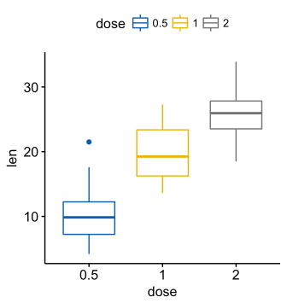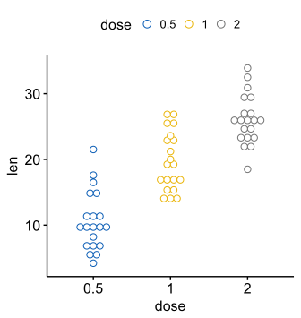

Arrange multiple ggplots on the same page

* **Create an ordered bar plot and a scatter plot**:

Create ordered bar plots. Change the fill color by the grouping variable “cyl”. Sorting will be done globally, but not by groups.

# Bar plot (bp) bp <- ggbarplot(mtcars, x = "name", y = "mpg", fill = "cyl", # change fill color by cyl color = "white", # Set bar border colors to white palette = "jco", # jco journal color palett. see ?ggpar sort.val = "asc", # Sort the value in ascending order sort.by.groups = TRUE, # Sort inside each group x.text.angle = 90 # Rotate vertically x axis texts ) bp + font("x.text", size = 8) # Scatter plots (sp) sp <- ggscatter(mtcars, x = "wt", y = "mpg", add = "reg.line", # Add regression line conf.int = TRUE, # Add confidence interval color = "cyl", palette = "jco", # Color by groups "cyl" shape = "cyl" # Change point shape by groups "cyl" )+ stat\_cor(aes(color = cyl), label.x = 3) # Add correlation coefficient sp

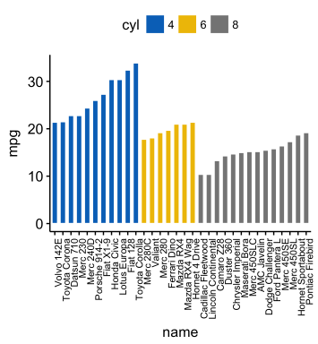

Arrange multiple ggplots on the same page

Alternatively, you can also use the function **plot\_grid**() [in **cowplot**]:

library("cowplot") plot\_grid(bxp, dp, bp + rremove("x.text"), labels = c("A", "B", "C"), ncol = 2, nrow = 2)

or, the function **grid.arrange**() [in **gridExtra**]:

library("gridExtra") grid.arrange(bxp, dp, bp + rremove("x.text"), ncol = 2, nrow = 2)

**Annotate the arranged figure**

R function: **annotate\_figure**() [in ggpubr].

figure <- ggarrange(sp, bp + font("x.text", size = 10), ncol = 1, nrow = 2) annotate\_figure(figure, top = text\_grob("Visualizing mpg", color = "red", face = "bold", size = 14), bottom = text\_grob("Data source: \n mtcars data set", color = "blue", hjust = 1, x = 1, face = "italic", size = 10), left = text\_grob("Figure arranged using ggpubr", color = "green", rot = 90), right = "I'm done, thanks :-)!", fig.lab = "Figure 1", fig.lab.face = "bold" )

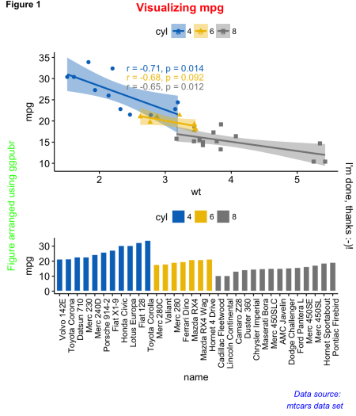

Arrange multiple ggplots on the same page

[Note](https://www.amazon.com/s/ref=nb_sb_noss?url=search-alias%3Daps&field-keywords=note) that, the function annotate\_figure() supports any ggplots.

**Align plot panels**

A real use case is, for example, when plotting [survival curves](http://www.sthda.com/english/wiki/survival-analysis-basics" \t "_blank) with the risk table placed under the main plot.

To illustrate this [case](http://rover.ebay.com/rover/13/0/19/DealFrame/DealFrame.cmp?bm=262&BEFID=93768&acode=259&code=259&aon=&crawler_id=521273&dealId=tNy_VBtILm-z0eNqwcHQtQ%3D%3D&searchID=&url=https%3A%2F%2Fwww.shoemall.com%2Fproduct%2Fanna-by-anuschka-smart-phone-case-wallet%2F1070985-3%3Futm_source%3DShoppingCPA2%26utm_medium%3DCSE%26utm_campaign%3DCSE%26CAWELAID%3D330007400007388805%26mid%3D521273%26sdc_id%3D%7Bsdc_id%7D&DealName=Anna%20by%20Anuschka%20Smart%20Phone%20Case%20%26%20Wallet%20Multi%20Misc%20Accessories%20No%20Size&MerchantID=521273&HasLink=yes&category=0&AR=-1&NG=1&GR=1&ND=1&PN=1&RR=-1&ST=&MN=msnFeed&FPT=SDCF&NDS=1&NMS=1&NDP=1&MRS=&PD=0&brnId=2455&lnkId=8070676&Issdt=170729051318&IsFtr=0&IsSmart=0&dlprc=81.95&SKU=538460BUT), we’ll use the survminer package. First, install it using *install.packages(“survminer”)*, then type this:

# Fit survival curves library(survival) fit <- survfit( Surv(time, status) ~ adhere, data = colon ) # Plot survival curves library(survminer) ggsurv <- ggsurvplot(fit, data = colon, palette = "jco", # jco palette pval = TRUE, pval.coord = c(500, 0.4), # Add p-value risk.table = TRUE # Add risk table ) names(ggsurv)

[1] "plot" "table" "data.survplot" "data.survtable"

ggsurv is a list including the components:

* *plot*: survival curves
* *table*: the risk table plot

You can arrange the survival plot and the risk table as follow:

ggarrange(ggsurv$plot, ggsurv$table, heights = c(2, 0.7), ncol = 1, nrow = 2)

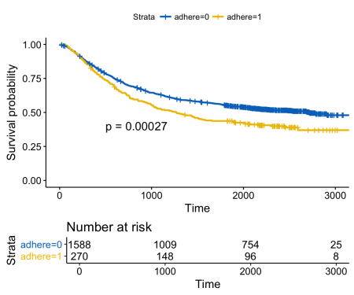

Arrange multiple ggplots on the same page

It can be seen that the [axes](http://www.amazon.com/gp/search?ie=UTF8&camp=1789&creative=9325&index=aps&keywords=axes&linkCode=ur2) of the survival plot and the risk table are not aligned vertically. To align them, specify the argument **align** as follow.

ggarrange(ggsurv$plot, ggsurv$table, heights = c(2, 0.7), ncol = 1, nrow = 2, align = "v")

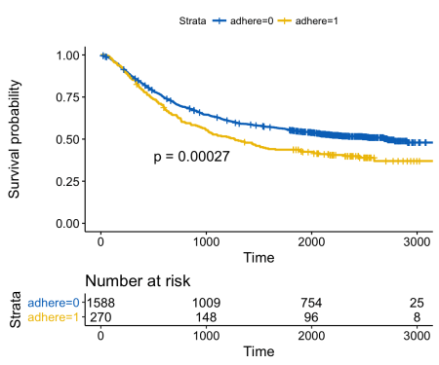

Arrange multiple ggplots on the same page

**Change column/row span of a plot**

**Use ggpubr R package**

We’ll use nested **ggarrange**() functions to change column/row span of plots.

For example, using the R code below:

* the scatter plot (sp) will live in the first row and spans over two columns
* the box plot (bxp) and the dot plot (dp) will be first arranged and will live in the second row with two different columns

ggarrange(sp, # First row with scatter plot ggarrange(bxp, dp, ncol = 2, labels = c("B", "C")), # Second row with box and dot plots nrow = 2, labels = "A" # Labels of the scatter plot )

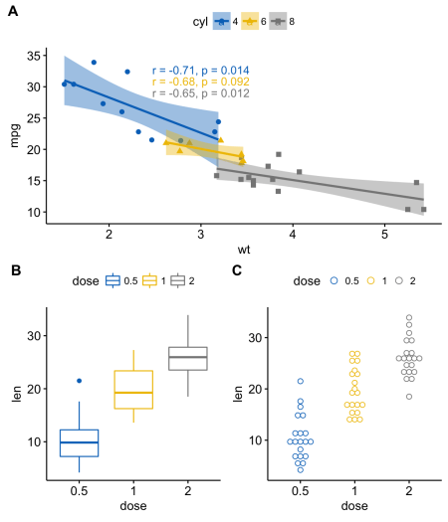

Arrange multiple ggplots on the same page

**Use cowplot R package**

The combination of the functions **ggdraw**() + **draw\_plot**() + **draw\_plot\_label**() [in **cowplot**] can be used to place graphs at particular locations with a particular size.

**ggdraw(). Initialize an empty drawing canvas**:

ggdraw()

[Note](https://www.amazon.com/s/ref=nb_sb_noss?url=search-alias%3Daps&field-keywords=note) that, by default, coordinates run from 0 to 1, and the point (0, 0) is in the lower left corner of the canvas (see the figure below).

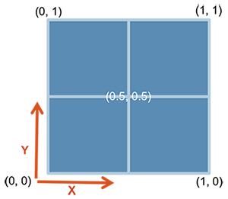

**draw\_plot(). Places a plot somewhere onto the drawing canvas**:

draw\_plot(plot, x = 0, y = 0, width = 1, height = 1)

* *plot*: the plot to place ([ggplot2](https://www.amazon.com/ggplot2-Elegant-Graphics-Data-Analysis/dp/331924275X) or a gtable)
* *x, y*: The x/y location of the lower left corner of the plot.
* *width, height*: the width and the height of the plot

**draw\_plot\_label()**. Adds a plot label to the upper left corner of a graph. It can handle vectors of labels with associated coordinates.

draw\_plot\_label(label, x = 0, y = 1, size = 16, ...)

* *label*: a vector of labels to be drawn
* *x, y*: Vector containing the x and y position of the labels, respectively.
* *size*: Font size of the label to be drawn

For example, you can combine multiple plots, with particular locations and different sizes, as follow:

library("cowplot") ggdraw() + draw\_plot(bxp, x = 0, y = .5, width = .5, height = .5) + draw\_plot(dp, x = .5, y = .5, width = .5, height = .5) + draw\_plot(bp, x = 0, y = 0, width = 1, height = 0.5) + draw\_plot\_label(label = c("A", "B", "C"), size = 15, x = c(0, 0.5, 0), y = c(1, 1, 0.5))

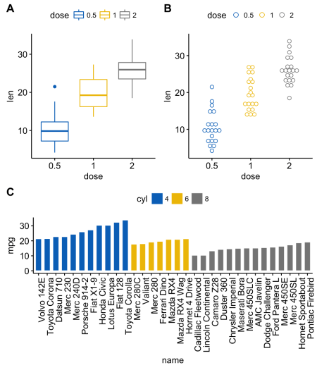

Arrange multiple ggplots on the same page

**Use gridExtra R package**

The function **arrangeGrop**() [in **gridExtra**] helps to change the row/column span of a plot.

For example, using the R code below:

* the scatter plot (sp) will live in the first row and spans over two columns
* the box plot (bxp) and the dot plot (dp) will live in the second row with two plots in two different columns

library("gridExtra") grid.arrange(sp, # First row with one plot spaning over 2 columns arrangeGrob(bxp, dp, ncol = 2), # Second row with 2 plots in 2 different columns nrow = 2) # Number of rows

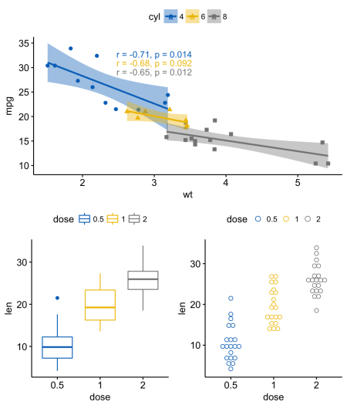

Arrange multiple ggplots on the same page

It’s also possible to use the argument **layout\_matrix** in the **grid.arrange**() function, to create a complex layout.

In the R code below *layout\_matrix* is a 2x2 matrix (2 columns and 2 rows). The first row is all 1s, that’s where the first plot lives, spanning the two columns; the second row contains plots 2 and 3 each occupying one column.

grid.arrange(bp, # bar plot spaning two columns bxp, sp, # box plot and scatter plot ncol = 2, nrow = 2, layout\_matrix = rbind(c(1,1), c(2,3)))

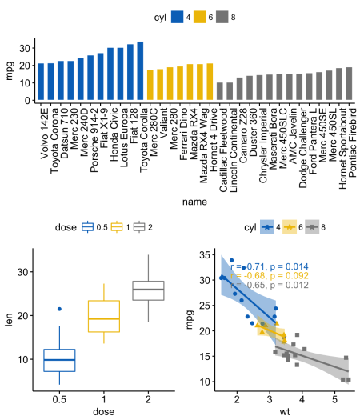

Arrange multiple ggplots on the same page

[Note](https://www.amazon.com/s/ref=nb_sb_noss?url=search-alias%3Daps&field-keywords=note) that, it’s also possible to annotate the output of the *grid.arrange*() function using the helper function **draw\_plot\_label**() [in cowplot].

To easily annotate the *grid.arrange*() / *arrangeGrob*() output (a gtable), you should first transform it to a [ggplot](https://www.udemy.com/data-visualization-in-r/) using the function *as\_ggplot*() [in ggpubr ]. Next you can annotate it using the function *draw\_plot\_label*() [in cowplot].

library("gridExtra") library("cowplot") # Arrange plots using arrangeGrob # returns a gtable (gt) gt <- arrangeGrob(bp, # bar plot spaning two columns bxp, sp, # box plot and scatter plot ncol = 2, nrow = 2, layout\_matrix = rbind(c(1,1), c(2,3))) # Add labels to the arranged plots p <- as\_ggplot(gt) + # transform to a [ggplot](https://www.udemy.com/data-visualization-in-r/) draw\_plot\_label(label = c("A", "B", "C"), size = 15, x = c(0, 0, 0.5), y = c(1, 0.5, 0.5)) # Add labels p

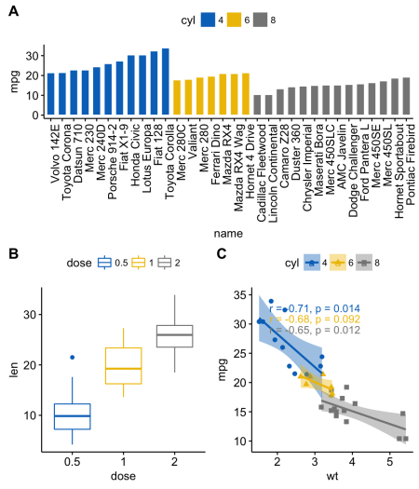

Arrange multiple ggplots on the same page

In the above R code, we used *arrangeGrob*() instead of *grid.arrange*().

[Note](https://www.amazon.com/s/ref=nb_sb_noss?url=search-alias%3Daps&field-keywords=note) that, the main difference between these two functions is that, *grid.arrange*() draw automatically the output of the arranged plots.

As we want to annotate the arranged plots before drawing it, the function *arrangeGrob*() is preferred in this [case](http://rover.ebay.com/rover/13/0/19/DealFrame/DealFrame.cmp?bm=262&BEFID=93768&acode=259&code=259&aon=&crawler_id=521273&dealId=tNy_VBtILm-z0eNqwcHQtQ%3D%3D&searchID=&url=https%3A%2F%2Fwww.shoemall.com%2Fproduct%2Fanna-by-anuschka-smart-phone-case-wallet%2F1070985-3%3Futm_source%3DShoppingCPA2%26utm_medium%3DCSE%26utm_campaign%3DCSE%26CAWELAID%3D330007400007388805%26mid%3D521273%26sdc_id%3D%7Bsdc_id%7D&DealName=Anna%20by%20Anuschka%20Smart%20Phone%20Case%20%26%20Wallet%20Multi%20Misc%20Accessories%20No%20Size&MerchantID=521273&HasLink=yes&category=0&AR=-1&NG=1&GR=1&ND=1&PN=1&RR=-1&ST=&MN=msnFeed&FPT=SDCF&NDS=1&NMS=1&NDP=1&MRS=&PD=0&brnId=2455&lnkId=8070676&Issdt=170729051318&IsFtr=0&IsSmart=0&dlprc=81.95&SKU=538460BUT).

**Use grid R package**

The grid R package can be used to create a complex layout with the help of the function **grid.layout**(). It provides also the helper function **viewport**() to define a region or a viewport on the layout. The function **print**() is used to place plots in a specified region.

The different steps can be summarized as follow :

1. Create plots : p1, p2, p3, ….
2. Move to a new page on a grid device using the function **grid.newpage**()
3. Create a layout 2X2 - number of columns = 2; number of rows = 2
4. Define a grid viewport : a rectangular region on a graphics device
5. Print a plot into the viewport

library(grid) # Move to a new page grid.newpage() # Create layout : nrow = 3, ncol = 2 pushViewport(viewport(layout = grid.layout(nrow = 3, ncol = 2))) # A helper function to define a region on the layout define\_region <- function(row, col){ viewport(layout.pos.row = row, layout.pos.col = col) } # Arrange the plots print(sp, vp = define\_region(row = 1, col = 1:2)) # Span over two columns print(bxp, vp = define\_region(row = 2, col = 1)) print(dp, vp = define\_region(row = 2, col = 2)) print(bp + rremove("x.text"), vp = define\_region(row = 3, col = 1:2))

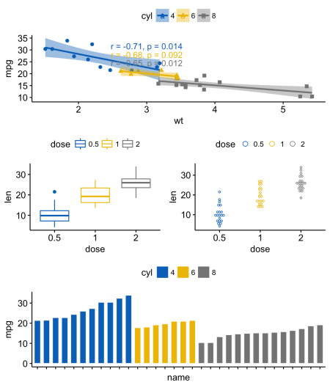

Arrange multiple ggplots on the same page

**Use common legend for combined ggplots**

To place a common unique legend in the margin of the arranged plots, the function **ggarrange**() [in ggpubr] can be used with the following arguments:

* *common.legend = TRUE*: place a common legend in a margin
* *legend*: specify the legend position. Allowed values include one of c(“top”, “bottom”, “left”, “right”)

ggarrange(bxp, dp, labels = c("A", "B"), common.legend = TRUE, legend = "bottom")

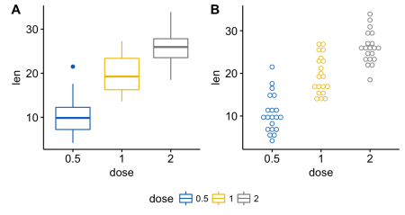

Arrange multiple ggplots on the same page

**Scatter plot with marginal density plots**

# Scatter plot colored by groups ("Species") sp <- ggscatter(iris, x = "Sepal.Length", y = "Sepal.Width", color = "Species", palette = "jco", size = 3, alpha = 0.6)+ border() # Marginal density plot of x (top panel) and y (right panel) xplot <- ggdensity(iris, "Sepal.Length", fill = "Species", palette = "jco") yplot <- ggdensity(iris, "Sepal.Width", fill = "Species", palette = "jco")+ rotate() # Cleaning the plots yplot <- yplot + clean\_theme() xplot <- xplot + clean\_theme() # Arranging the plot ggarrange(xplot, NULL, sp, yplot, ncol = 2, nrow = 2, align = "hv", widths = c(2, 1), heights = c(1, 2), common.legend = TRUE)

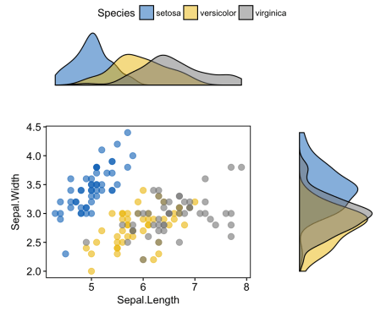

Arrange multiple ggplots on the same page

**Mix table, text and** [**ggplot2**](https://www.amazon.com/ggplot2-Elegant-Graphics-Data-Analysis/dp/331924275X) **graphs**

In this section, we’ll show how to plot a table and text alongside a chart. The iris data set will be used.

We start by creating the following plots:

1. a **density plot** of the variable “Sepal.Length”. R function: **ggdensity**() [in ggpubr]
2. a plot of the **summary table** containing the descriptive statistics (mean, [sd](https://www.amazon.com/s/ref=nb_sb_noss?url=search-alias%3Daps&field-keywords=sd), … ) of Sepal.Length.
   * R function for computing descriptive statistics: **desc\_statby**() [in ggpubr].
   * R function to draw a textual table: **ggtexttable**() [in ggpubr].
3. a plot of a text **paragraph**. R function: **ggparagraph**() [in ggpubr].

We finish by arranging/combining the three plots using the function **ggarrange**() [in ggpubr]

# Density plot of "Sepal.Length" #:::::::::::::::::::::::::::::::::::::: density.p <- ggdensity(iris, x = "Sepal.Length", fill = "Species", palette = "jco") # Draw the summary table of Sepal.Length #:::::::::::::::::::::::::::::::::::::: # Compute descriptive statistics by groups stable <- desc\_statby(iris, measure.var = "Sepal.Length", grps = "Species") stable <- stable[, c("Species", "length", "mean", "[sd](https://www.amazon.com/s/ref=nb_sb_noss?url=search-alias%3Daps&field-keywords=sd)")] # Summary table plot, medium orange theme stable.p <- ggtexttable(stable, rows = NULL, theme = ttheme("mOrange")) # Draw text #:::::::::::::::::::::::::::::::::::::: text <- paste("iris data set gives the measurements in cm", "of the variables sepal length and width", "and petal length and width, respectively,", "for 50 flowers from each of 3 species of iris.", "The species are Iris setosa, versicolor, and virginica.", sep = " ") text.p <- ggparagraph(text = text, face = "italic", size = 11, color = "black") # Arrange the plots on the same page ggarrange(density.p, stable.p, text.p, ncol = 1, nrow = 3, heights = c(1, 0.5, 0.3))

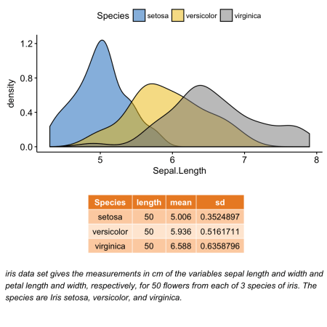

Arrange multiple ggplots on the same page

**Insert a graphical element inside a** [**ggplot**](https://www.udemy.com/data-visualization-in-r/)

The function **annotation\_custom**() [in ggplot2] can be used for adding tables, plots or other grid-based elements within the plotting area of a ggplot. The simplified format is :

annotation\_custom(grob, xmin, xmax, ymin, ymax)

* **grob**: the external graphical element to display
* **xmin, xmax** : x location in data coordinates (horizontal location)
* **ymin, ymax** : y location in data coordinates (vertical location)

**Place a table within a** [**ggplot**](https://www.udemy.com/data-visualization-in-r/)

We’ll use the plots - density.p and stable.p - created in the previous section (@ref(mix-table-text-and-ggplot)).

density.p + annotation\_custom(ggplotGrob(stable.p), xmin = 5.5, ymin = 0.7, xmax = 8)

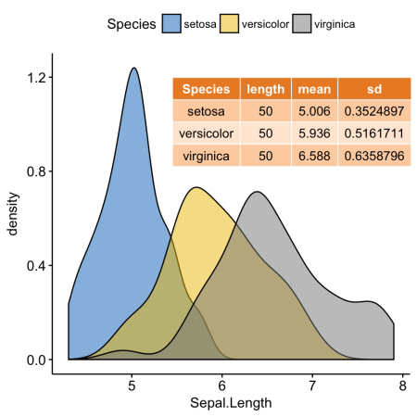

Arrange multiple ggplots on the same page

**Place a box plot within a** [**ggplot**](https://www.udemy.com/data-visualization-in-r/)

1. Create a scatter plot of y = “Sepal.Width” by x = “Sepal.Length” using the iris data set. R function **ggscatter**() [ggpubr]
2. Create separately the box plot of x and y variables with transparent background. R function: **ggboxplot**() [ggpubr].
3. Transform the box plots into graphical objects called a “grop” in Grid terminology. R function **ggplotGrob**() [ggplot2].
4. Place the box plot grobs inside the scatter plot. R function: **annotation\_custom**() [ggplot2].

As the inset box plot overlaps with some points, a *transparent background* is used for the box plots.

# Scatter plot colored by groups ("Species") #:::::::::::::::::::::::::::::::::::::::::::::::::::::::::: sp <- ggscatter(iris, x = "Sepal.Length", y = "Sepal.Width", color = "Species", palette = "jco", size = 3, alpha = 0.6) # Create box plots of x/y variables #:::::::::::::::::::::::::::::::::::::::::::::::::::::::::: # Box plot of the x variable xbp <- ggboxplot(iris$Sepal.Length, width = 0.3, fill = "lightgray") + rotate() + theme\_transparent() # Box plot of the y variable ybp <- ggboxplot(iris$Sepal.Width, width = 0.3, fill = "lightgray") + theme\_transparent() # Create the external graphical objects # called a "grop" in Grid terminology xbp\_grob <- ggplotGrob(xbp) ybp\_grob <- ggplotGrob(ybp) # Place box plots inside the scatter plot #:::::::::::::::::::::::::::::::::::::::::::::::::::::::::: xmin <- min(iris$Sepal.Length); xmax <- max(iris$Sepal.Length) ymin <- min(iris$Sepal.Width); ymax <- max(iris$Sepal.Width) yoffset <- (1/15)\*ymax; xoffset <- (1/15)\*xmax # Insert xbp\_grob inside the scatter plot sp + annotation\_custom(grob = xbp\_grob, xmin = xmin, xmax = xmax, ymin = ymin-yoffset, ymax = ymin+yoffset) + # Insert ybp\_grob inside the scatter plot annotation\_custom(grob = ybp\_grob, xmin = xmin-xoffset, xmax = xmin+xoffset, ymin = ymin, ymax = ymax)

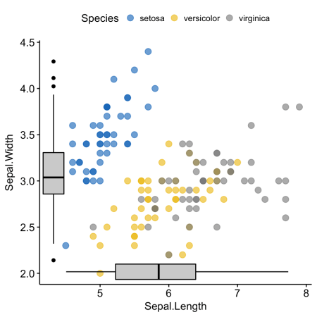

Arrange multiple ggplots on the same page

**Add background image to ggplot2 graphs**

**Import the background image**. Use either the function **readJPEG**() [in *jpeg* package] or the function **readPNG**() [in *png* package] depending on the format of the background image.

To test the example below, make sure that the *png* package is installed. You can install it using install.packages(“png”) R command.

# Import the image img.file <- system.file(file.path("images", "background-image.png"), package = "ggpubr") img <- png::readPNG(img.file)

**Combine a ggplot with the background image**. R function: **background\_image**() [in ggpubr].

library(ggplot2) library(ggpubr) ggplot(iris, aes(Species, Sepal.Length))+ background\_image(img)+ geom\_boxplot(aes(fill = Species), color = "white")+ fill\_palette("jco")

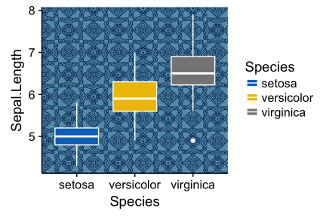

Arrange multiple ggplots on the same page

Change box plot fill color transparency by specifying the argument alpha. Value should be in [0, 1], where 0 is full transparency and 1 is no transparency.

library(ggplot2) library(ggpubr) ggplot(iris, aes(Species, Sepal.Length))+ background\_image(img)+ geom\_boxplot(aes(fill = Species), color = "white", alpha = 0.5)+ fill\_palette("jco")

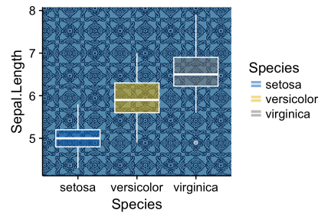

Arrange multiple ggplots on the same page

Another example, overlaying the France map and a ggplot2:

mypngfile <- download.file("<https://upload.wikimedia.org/wikipedia/commons/thumb/e/e4/France_Flag_Map.svg/612px-France_Flag_Map.svg.png>", destfile = "france.png", mode = 'wb') img <- png::readPNG('france.png') ggplot(iris, aes(x = Sepal.Length, y = Sepal.Width)) + background\_image(img)+ geom\_point(aes(color = Species), alpha = 0.6, size = 5)+ color\_palette("jco")+ theme(legend.position = "top")

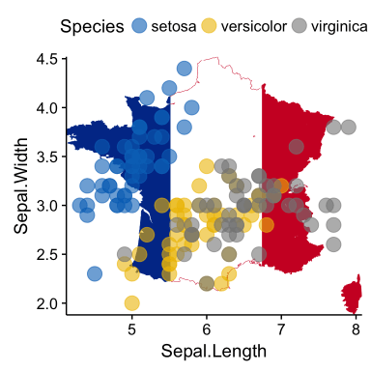

Arrange multiple ggplots on the same page

**Arrange over multiple pages**

If you have a long list of ggplots, say n = 20 plots, you may want to arrange the plots and to place them on multiple pages. With 4 plots per page, you need 5 pages to hold the 20 plots.

The function **ggarrange**() [in ggpubr] provides a convenient solution to arrange multiple ggplots over multiple pages. After specifying the arguments *nrow* and *ncol*, the function **ggarrange**() computes automatically the number of pages required to hold the list of the plots. It returns a list of arranged ggplots.

For example the following R code,

multi.page <- ggarrange(bxp, dp, bp, sp, nrow = 1, ncol = 2)

returns a list of two pages with two plots per page. You can visualize each page as follow:

multi.page[[1]] # Visualize page 1 multi.page[[2]] # Visualize page 2

You can also export the arranged plots to a pdf file using the function **ggexport**() [in ggpubr]:

ggexport(multi.page, filename = "multi.page.ggplot2.pdf")

PDF file: [Multi.page.ggplot2](http://www.slideshare.net/kassambara/multipageggplot2" \t "_blank)

<br />

Note that, it’s also possible to use the function **marrangeGrob()** [in gridExtra] to create a multi-pages output.

library(gridExtra) res <- marrangeGrob(list(bxp, dp, bp, sp), nrow = 1, ncol = 2) # Export to a pdf file ggexport(res, filename = "multi.page.ggplot2.pdf") # Visualize interactively res

**Nested layout with ggarrange()**

We’ll arrange the plot created in section (@ref(mix-table-text-and-ggplot)) and (@ref(create-some-plots)).

p1 <- ggarrange(sp, bp + font("x.text", size = 9), ncol = 1, nrow = 2) p2 <- ggarrange(density.p, stable.p, text.p, ncol = 1, nrow = 3, heights = c(1, 0.5, 0.3)) ggarrange(p1, p2, ncol = 2, nrow = 1)

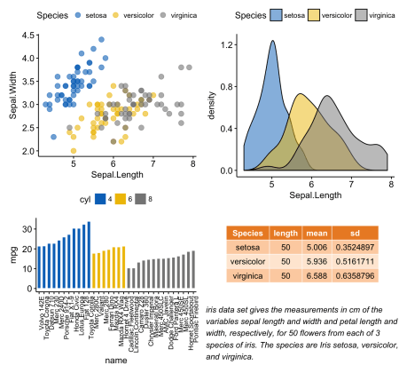

Arrange multiple ggplots on the same page

**Export plots**

R function: **ggexport**() [in ggpubr].

First, create a list of 4 ggplots corresponding to the variables Sepal.Length, Sepal.Width, Petal.Length and Petal.Width in the iris data set.

plots <- ggboxplot(iris, x = "Species", y = c("Sepal.Length", "Sepal.Width", "Petal.Length", "Petal.Width"), color = "Species", palette = "jco" ) plots[[1]] # Print the first plot plots[[2]] # Print the second plots and so on...

Next, you can export individual plots to a file (pdf, eps or png) (one plot per page). It’s also possible to arrange the plots (2 plot per page) when exporting them.

Export individual plots to a pdf file (one plot per page):

ggexport(plotlist = plots, filename = "test.pdf")

Arrange and export. Specify nrow and ncol to display multiple plots on the same page:

ggexport(plotlist = plots, filename = "test.pdf", nrow = 2, ncol = 1)

**Acknoweledgment**

We sincerely thank all developers for their efforts behind the packages that ggpubr depends on, namely:

* Baptiste Auguie (2016). gridExtra: Miscellaneous Functions for “Grid” Graphics. R package version 2.2.1. [https://CRAN.R-project.org/package=gridExtra](https://cran.r-project.org/package=gridExtra" \t "_blank)
* [Claus O](http://rd.bizrate.com/rd?t=http%3A%2F%2Fwww.amazon.com%2Fdp%2FB01JRUXAYG%2Fref%3Dasc_df_B01JRUXAYG5094398%3Fsmid%3DA3JEJ4DLYN3UAF%26tag%3Dshopz0d-20%26ascsubtag%3Dshopzilla_mp_1303-20%3BSZ_REDIRECT_ID%26linkCode%3Ddf0%26creative%3D395105%26creativeASIN%3DB01JRUXAYG&mid=184059&cat_id=20000001&atom=10678&prod_id=&oid=7934262783&pos=1&b_id=18&bid_type=4&bamt=823abe7ec9c4bc8a&cobrand=1&ppr=16ae62ccc484c371&rf=af1&af_assettype_id=12&af_creative_id=2973&af_id=615103&af_placement_id=1&dv=4cc4a800dc2596cec3395eadf6ab8571). Wilke (2016). cowplot: Streamlined Plot Theme and Plot Annotations for ‘ggplot2’. R package version 0.7.0. [https://CRAN.R-project.org/package=cowplot](https://cran.r-project.org/package=cowplot" \t "_blank)
* H. Wickham. ggplot2: Elegant Graphics for Data Analysis. Springer-Verlag New York, 2009.

**Infos**

This analysis has been performed using **R** [**software**](http://rd.bizrate.com/rd?t=http%3A%2F%2Ftracking.searchmarketing.com%2Fclick.asp%3Faid%3D120216680000041493%26szredirectid%3DSZ_REDIRECT_ID&mid=257468&cat_id=25000300&atom=10699&prod_id=&oid=5997156189&pos=1&b_id=18&bid_type=8&bamt=be85fa8f6ad737f6&cobrand=1&ppr=a9732a8a6c7e0d03&rf=af1&af_assettype_id=12&af_creative_id=2973&af_id=615103&af_placement_id=1&dv=4195365d7de8d0d4f65b0c71821d2a5b) (ver. 3.3.2) and **ggpubr** (ver. 0.1.4.999).